Visible Light Driven Improved Photodegradation Efficiency of RhB Dye Over Nano-structured SnS/BiVO₄ (p/n-type) Photocatalyst

Govinda Dharmana ^{1, a)}, Santhosh Kumar Nadikatla ^{1, b)},
Thirumala Rao Gurugubelli ^{2, c)}, and Ravindranadh Koutavarapu ^{1, d)}

¹ Physics Division, Department of Basic Sciences & Humanities, GMR Institute of Technology, Rajam 532127, Andhra Pradesh, India
² Department of Physics, School of Sciences, SR University, Warangal 506371, Telangana, India

^{c)} Corresponding author: thirumala.phy@gmail.com
^{d)} Corresponding author: ravindranadh.k@gmrit.edu.in
^{a)} govinda.d@gmrit.edu.in
^{b)} santoshkumar.n@gmrit.edu.in

Abstract: Photodegradation efficiency of hydrothermally fabricated (at 180⁰ for 12 hours) pristine SnS and BiVO₄, SnS/BiVO₄ (SBV) is briefed. Yield nanocomposites are tested under various spectral, surface and optical techniques like powder XRD, TEM, XPS, UV-DRS and detailed photocatalytic study is also discussed. Results are revealed that XRD exhibits orthorhombic (SnS) and monoclinic phase formation with more agglomeration behavior and no more other peaks also observed in XRD pattern which reflect the substantial formation of heterostructure. TEM micrographs infer the nanosheets and/or tiny nanorod like structure with rough surface and also more agglomerated trend also noticed. XPS disclosed that tri-valence appearance of Bi element in SBV composite along with other constitute elements and also some environmental effective peaks also noticed in survey scan spectrum. DRS study revealed the reduced bandgap for SBV composite than that of bare SnS and BiVO₄, which infer the red shift trend. The obtained RhB dye degradation capacity in SBV heterostructure is around 96% in 120 minutes of light illumination. The SBV composite perform superior degradation than that of pure SnS and BiVO₄ owing to huge surface area and effective formation of heterostructure. Further, it is noticed that robust RhB degradation is also due to the utmost separation of photo-charge carriers and participation of free radicals and respective proposed mechanism also briefly presented. The stability test for prepared SBV composite to anticipate for further usage is also presented.
Keywords: SnS/BiVO₄, RhB dye, Photocatalysis, hydrothermal, pollutants

INTRODUCTION
Since few decades, contamination of fresh water bodies due to the various effluents from different sources is huge distress to human community and other well-being across the world. Industrial, agricultural, mining activity and pharmaceutical emitters are major cause to degrade the quality of water owing to the direct discharge from source to fresh water bodies, also reason for facing lot of health issues and other medical complications. To tackle this problem effectively, photocatalysis mechanism is very preferable than other conventional physical, chemical and biological methods owing to its exceptional characteristics such as eco-savvy, cost effective and uniform production [1]. In photocatalytic process, upon light incidence photo induced charges are transferred from one band to other band due to their matched band edge potential and also there will be an internal electric field also activated to stabilize the thermal equilibrium. In addition to this, departure of charge carriers on the surface of catalyst will lead to enlarge the surface area and represent its nano-phased state, which also encounter the generation of various free radicals such as hydroxyl, super oxide over the hydrolysis process to destroy the RhB dye molecule in wastewater [2]. Hence, in this way free radicals are substantially degrade the dye molecule structure by oxidation and/or reduction process to obtain robust degradation ability by leaving water and CO₂ and H₂O₂ as harmless degradation products at end of the process. Hence, photocatalysis process is placed in a first row than other conventional chemical/physical methods in accordance with effective degradation of the pollutants/nascent dyes in wastewater. As per reports, Rhodamine B (RhB) dye (Formula-C₂₈H₃₁CIN₂O₃, Molar mass-479.02) is extensively used in paper, paints, textiles and printing industries also which evidence for numerous health disorders. So, in current study RhB dye is targeted for the degradation studies in presence of as-prepared nanocomposites over visible light illumination. Moreover, the interface of different kind of semiconductor heterostructure (i.e., p/n-type) than that of other combinations like metal/semiconductor, same kind of semiconductor/semiconductor is substantially suitable in accordance with obtain efficient photodegradation owing to its tunable bandgap engineering and well structural appearance. In p/n-type novel structure, upon light irradiation the significant moment of electrons and holes is occurs between conduction and valance bands (CB and VB) due to their matched band edge potentials and generation of internal electric field at the interface [3]. Hence, in this study authors are mainly focused on the construction of different kind of semiconductor material interface i.e., p/n-type (SnS/BiVO₄) (SBV) heterostructure owing to their outstanding properties such as more stability, chemical nature, uniform production and environmentally safe. The main object behind the selecting SnS material is due to its unique features like less optical bandgap (~1.3 eV) high light absorption ability, active in visible light, wide availability and harmless which also used in various applications like [4] cells, storage, photocatalytic mechanism, electronic industry, sensors etc. To obtain better photocatalytic efficiency, SnS material is need to be couple with other kind of semiconductor material such as BiVO₄ a n-type semiconductor with bandgap (~2.4 eV), good catalyst material and high stability which clutched the much devotion by the researchers towards obtain superior photodegradation efficiency [5]. The matched CB and VB potential edge scenario shall promote the degradation efficiency of photocatalyst in line with migration of charge carriers and formation of novel heterostructure. And also, upon visible light illumination the induced charge carriers are transferred between the CB and equalent VB in order to obtain the internal electric filed at the interface of heterojunction of prepared photocatalyst. The main intension behind the current work is to obtain superior degradation of RhB dye using prepared catalyst by matching/interface the wide bandgap/narrow bandgap catalyst composites in order to achieve superior degradation under visible light illumination. The adopted hydrothermal method is also plays a crucial part in order to obtain substantial heterostructure due to its significant experimental conditions such as high temperature, high pressure and uniform production. The combination of SBV heterostructure is anticipated to reduce the toxic levels of wastewater in presence of visible light due to their matched bandgap position and location of VB and CB band edge potential, also extreme separation of induced charge carriers [6]. In present work, authors were targeted the preparation of novel heterostructure i.e., SBV owing to interface of different kind of semiconductors SBV (p/n-type) with different optical bandgap. This kind of large and narrow bandgap semiconductor interface shall promote the degradation efficiency of prepared photocatalyst. The prepared composites are anticipated to degrade the RhB dye molecule efficiently upon visible light illumination.
METHODOLOGY AND EXPERIMENTATION
Materials
The used high purity precursors for the preparation of SBV nanocomposites are Tin chloride [SnCl₄.5H₂O], Sodium Sulphide [Na₂S], Bismuth nitrate Penta-hydrate [Bi(NO₃)₃.5 H₂O], ammonium metavanadate [NH₄VO₃], Sodium hydroxide (NaOH), ethanol, Rhodamine B and deionized water.
Methodology
The typical experimental procedure involves the systematic preparation of SBV nanocomposites with equalent mole ratio (1:1) under hydrothermal conditions i.e., high temperature and pressure conditions. 0.1mol% of SnCl₄.5H₂O and equal mole of Na₂S are dissolved in 25 mL deionized water separately, and placed on high rpm magnetic stirrer for 2-3 hours at 80⁰c till formation of significant white solution called SnS. Further, 0.1 mol% of Bi(NO₃)₃.5 H₂O solution (dissolved in 25mL) is added to above SnS yield as drop wise while continuous stirring till formation of good homogeneous precipitation. While this fast stirring, the white solution is slowly turned into light-yellow colour which indicates the substantial dissolving of Bismuth in SnS solution, and 25 mL of NH₄VO₃ solution (0.1mol%) is added to above solution till formation of high concentrated yellow solution, Finally, 25 mL of NaOH solution is added to the above colloidal solution till formation of dark yellow solution which indicates the formation of SBV nanocomposite. After formation of required nanocomposite, NaOH is used to adjust pH of the prepared solution around at 10.5. Further, the pH adjusted solution is taken into 100 mL and 150 mL Teflon coated autoclaves and placed in high temperature muffle furnace operated at 180⁰c for 12 hours, after this step the solution is washed with deionized water to remove contaminates then after solution is allowed for centrifuge at 5000rpm. The centrifuged solution is again washed and placed in oven at 100⁰c for 3 hours, then allowed for mechanical grinding till acquiring fine powder without any grain sized particles. The prepared solution under hydrothermal conditions is made substantial without any contaminates which also favorable to exhibit better photocatalytic activity.
Experimental techniques
To obtain structural analysis of prepared samples, XRD graphs are taken on the PANalytical X-Pert diffractometer device with CuKα radiation, for morphological study TEM graphs are recorded on the device HITACHI H-7650.To confirm the surface analysis and valance state of constitutional elements, Thermo Scientific K-alpha instrument is used. To estimate the optical bandgap of synthesized samples, optical absorption (UV-DRS) spectrum is taken on JASCO V-670 instrument. Photocatalytic degradation studies of RhB dye is observed with UV-visible annular photoreactor (HIPR-MP400) under 150W visible light illumination for 120 minutes.
RESULTS AND DISCUSSION
XRD structural study
Powder XRD analysis reveal the phase formation and structural arrangement of the as-synthesized samples (SnS, BiVO₄ and SBV), and also the respective XRD patterns are presented in Figure 1. As shown in diagram, in SBV pattern equal number of peaks is observed owing to substantial formation of nanocomposite, and also peaks are seems to be appearing in equal width and height which indicate the formation of better heterostructure.
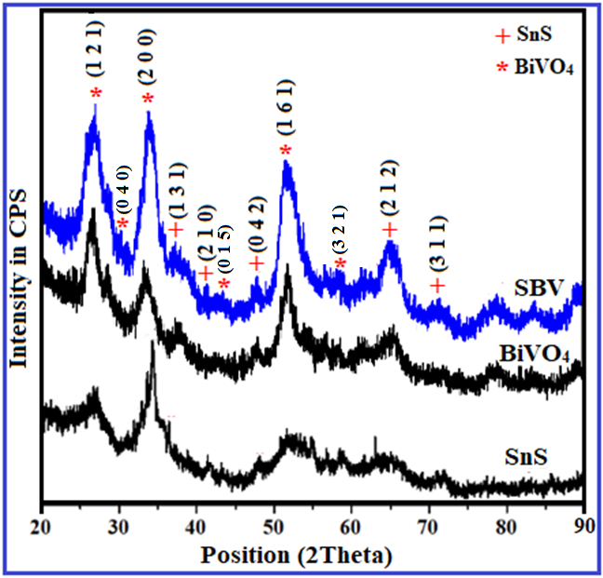
FIGURE 1. XRD patterns of SnS, BiVO₄ and SBV composites
From figure, it is clear that SnS peaks located at the angles 36.8, 41.2, 47.1 and 71.2⁰ which depict the planes (131), (210), (042) (212) and (311), respectively and exhibit orthorhombic structure in line with JCPDS (39-0354) [7]. Further, BiVO₄ diffraction peaks observed at 27.7, 30.6, 34.2, 43.3, 51.4 and 58.7⁰ corresponding to miller planes (121), (0 4 0), (200), (0 1 5), (161) and (3 2 1), respectively, and display the monoclinic structure in accordance with JCPDS (14-0688) [8]. The crystallite size (D) of the synthesized samples is evaluated by using below expression:
D = $\frac{0.9 λ }{β cosθ}$ nm
The terms wavelength, full width at half maxima, and diffraction angle are all used in the expression. The prepared samples' microstrain (ε) and dislocation density (δ) were calculated using the methods listed below:
ε = $\frac{β cosθ}{4}$ and δ = $\frac{1}{D^{2}}$
Moreover, the functional behavior of the prepared samples in terms of grain size, d-spacing, strain and density are depicted in Figure 2, and the steep fall trend was noticed from the functional parameters against all samples.
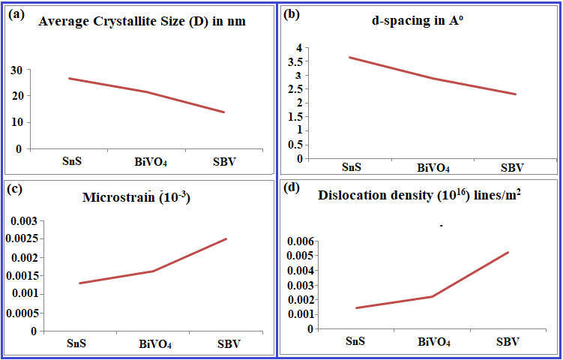
FIGURE 2. The functional behavior of SnS, BiVO₄ and SBV nanocomposites
TEM analysis
The morphological behavior of the prepared samples is designated by TEM analysis, which also indicates the nanosheets and /or nanorod like structures as presented in Figure 3. As shown in Figure 3(a), SnS composite appeared as nanosheets and tiny rod like structures with uneven distribution and wavy surface, and Figure 3(b) demonstrate the crushed sheet like structure owing to non-uniform distribution of Bi atoms in composites. As presented in Figure 3(c), SnS nanostructure is highly masked by the BiVO₄ structure owing to the successful formation of heterostructure.
FIGURE 3. TEM micrographs of (a) SnS, (b) BiVO₄ and (c) SBV nanocomposite
XPS surface study
The chemical stability and oxidation states of existed elements in the prepared samples are examined by the XPS study, which also substantial evidence for the occurrence of different elements. The XPS scan spectrum with other elements is presented in Figure 4. As shown in Figure 4(a), XPS survey scan spectrum is recorded in the range of 0-1300eV with all constitute elements binding energy peaks along with carbon (C) and nitrogen (N) peaks aroused from environmental effect. The XPS spectrum of Tin (Sn²⁺) element [Figure 4(b)] argued two prominent peaks at binding energies 495.66 and 487.24eV corresponding to 3d_{3/2} and 3d_{5/2} states, respectively, with splitting of 8.42 eV [9]. Sulphur (S²⁻) element XPS spectra [Figure 4(c)] consist of two significant binding peaks at 168.33 and 160.89eV which ascribed to 2p_{1/2} and 2p_{3/2} states, respectively with spin state splitting of 7.44eV [10]. XPS spectrum related to Bismuth (Bi³⁺) element is presented in [Figure 4(d)], which reveal the position of two peaks at different energies at 162.3 and 155.8eV, which argued the 4f_{5/2} and 4f_{7/2} states, respectively with 6.5eV spin-orbit splitting [11]. The Vanadium (V⁵⁺) XPS spectrum [Figure 4(e)] shows one significant and weak peaks at 522.74 and 514.92eV corresponding to 2p1/2 and 2p3/2 states, respectively with splitting of 7.82 eV [12]. The oxygen (O²⁻) element XPS spectrum is depicted in [Figure 4(f)], which shows a single prominent peak observed at 531.62eV corresponding to 1s state [13]. Hence, XPS spectrum undoubtedly reveals the composition and valance state of constitute elements in the synthesized samples.
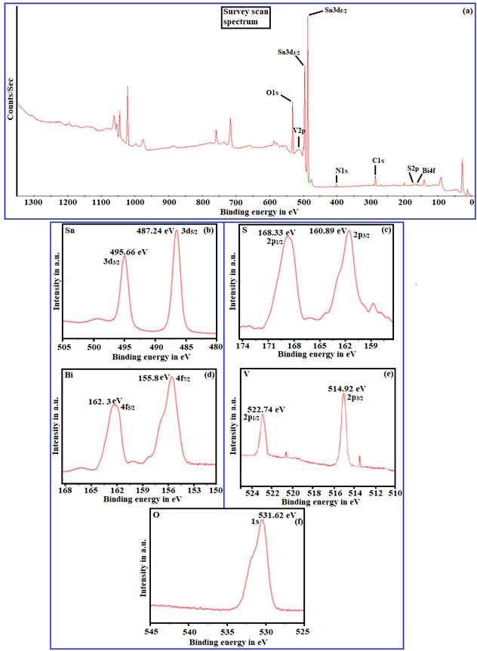
FIGURE 4. XPS spectrum of (a) survey scans (b) Sn, (c) S, (d) Bi, (e) V, (f) O elements for optimized sample
UV-DRS analysis
The optical absorption trend and bandgap nature of as-fabricated samples are designated by UV-DRS analysis and by drawing Tauc plots as depicted in Figure 5. As shown in Figure 5(a), the absorption peak corresponding to SBV composite trails the steep fall behavior and with a shoulder peak around at 420nm which indicate the absorption range in visible region corresponding to composite. The absorption peak point reveals that the composite is very active in visible region in accordance with separation of photoinduced charge carriers. The calculation of optical bandgap of SBV composite is presented in Figure 5(b). The Optical bandgap of SBV composite is found to be 1.02 eV, which is less than that of pristine SnS (1.42 eV) and BiVO₄ (2.38 eV). The low bandgap argue the red shift trend and reduced recombination rate of induced charge carriers which lead to superior performance of composite in order to degrade the dye pollutant upon light illumination [14].
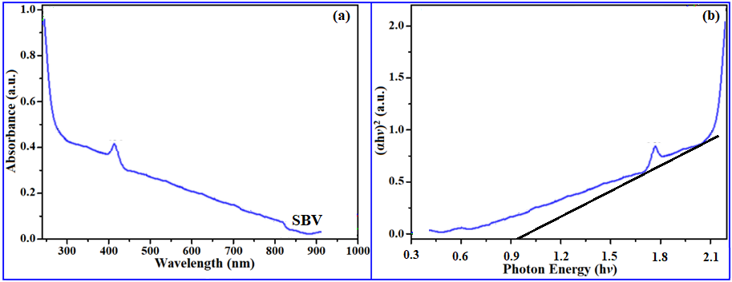
FIGURE 5. a) UV-DRS absorption spectrum, b) Tauc plot of SBV composite
Photocatalytic studies
Photocatalytic degradation regard to RhB against to SnS, BiVO₄ and SBV composites are depicted in Figure 6. As presented in Figure 6(a), upon visible light illumination (120 minutes), the prepared SBV NC display the prominent activity than that of bare SnS and BiVO₄ owing to band edge position and maximum departure of induced charge carriers. Initially, degradation activity is performed under blank (absence of catalyst) mode which unveil that aqueous solution is remains unchanged in colour, which indicate that dyes are active in catalyst medium. Further, 5mL of prepared solution is taken away in 15 minutes of interval time for the testing of dye decolorization, pure SnS couldn’t degrade significantly due to rapid recombination of charge carriers, which is not favorable for photodegradation and also pure BiVO₄ exhibit moderate performance in accordance with decolorization of dye molecule which implies that less surface area, low absorption capability of light and high bandgap (~2.34eV).
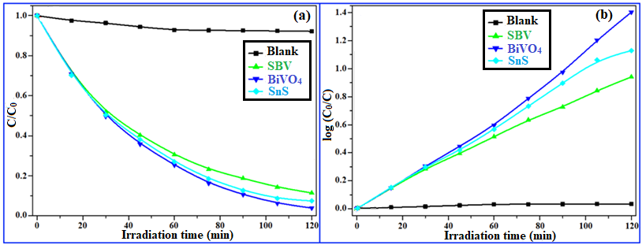

FIGURE 6. (a) Photocatalytic degradation curves (b) Kinetic studies of prepared nanocomposites

As presented in Figure 6(b), the degradation mechanism follows first order kinetics which infers the enhancing activity with increasing concentration of catalyst dosage. The superior photocatalytic ability is examined by using Langmuir-Hinshelwood method [15] over visible light illumination. The possible intrusion of BiVO₄ nanoparticles in SnS composite will play a vibrant role in achieving robust degradation activity. The degradation efficiency, kinetic nature and reusability of as-synthesized samples are depicted in Figure 7. The series order of degradation is noticed as SnS<BiVO₄<SBV upon continuous visible light illumination [Figure 7(a)], in another way the values of degradation capability are found to be 32.58, 48.35 and 96.52% for SnS, BiVO₄ and SBV NCs, respectively. The highest degradation for SBV NC is infer the quick departure of electron and holes which may leads to generation of internal electric field at the interface. The kinetic study [Figure 7(b)] of samples is anticipated to participation and/or acceleration of composites in order to obtain extreme photocatalytic activity. The chemical kinetic values of SnS, BiVO₄ and SBV NCs is observed as 0.0048, 0.0062 and 0.0118 min⁻¹, respectively, and also among all samples SBV NC hold highest rate due to active participation and formation of new energy level within the nano-phased regime. The usage of prepared NC for further applications were very essential, in line that recycling test [Figure 7(c)] is conducted for the SBV NC for three consecutive times, results infer that after three cycles also adopted sample was withstand its ability with minute loss (from 96.52 to 95.27). The recycling results ascribed that the prepared NC was greatly useful for the future practical applications [16].
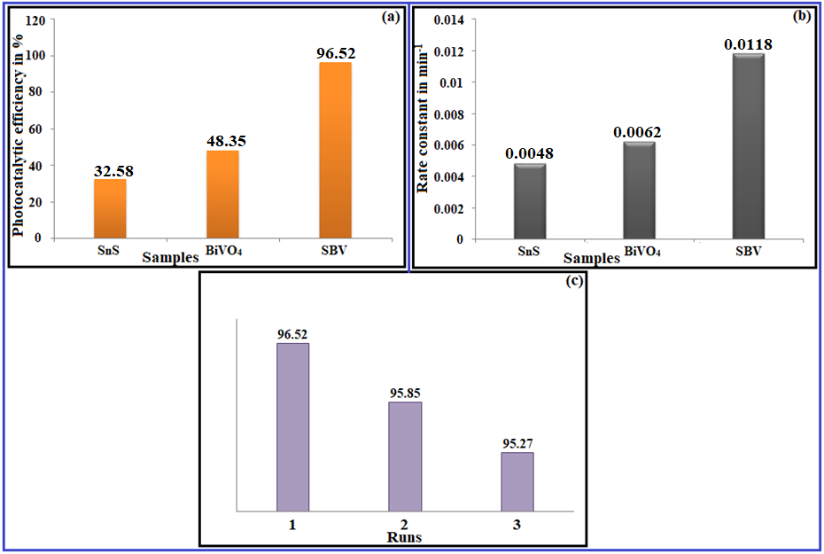

FIGURE 7. a) Degradation efficiency of samples (b) rate constant study (c) reusability results of prepared samples

Proposed charge separation mechanism

The migration of induced charge carriers on the surface of synthesized nanocomposite upon visible light irradiation is presented in Figure 8. As shown in figure, electrons and holes are excited in presence of light from conduction band (CB) to valance band (VB) and vice-versa, due to these transformations there will be possibility of production of internal electric field (E) at the heterostructure interface [17]. Electrons from CB of BiVO₄ are move to CB of SnS and also holes from VB of SnS are migrated to VB of BiVO₄, resultantly maximum departure of electron-holes will occurs in order to satisfy the thermal equilibrium state. The diffusion of charge carriers in opposite direction will lead to formation of very strong free radicals in order to destroy the structure of RhB dye molecule through the hydrolysis process. Further, in presence of light illumination photo-induced charge carriers are excite from the band positions and in turn its surface area is stretched in order yield robust photocatalytic ability, and also matched band edge potential of CB and VB bands are predominantly plays a major role in line with generation of electric field at the interface of heterostructure. The free radicals are substantially interacting with dye molecule in order to obtain harmless degradation products such as water and CO₂ by oxidation and reduction reactions. Hence, free radicals (particularly hydroxyl ions) play a vibrant role [18] in the process of degradation of RhB dye molecule and yield the non-harmful substances. In this way, our prepared nanocomposites are playing a vital role to reduce the toxic levels of water bodies and subsequent use of this purified water for people and their wellbeing.

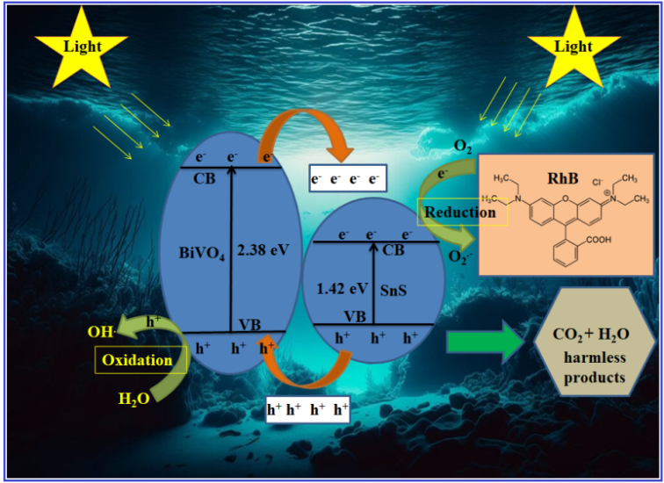

FIGURE 8. Proposed charge separation mechansim of SBV nanocomposite

CONCLUSION

In summary, hydrothermally synthesized SBV heterostructure infers the following conclusions such as XRD exhibits orthorhombic (SnS) and monoclinic phase formation with more agglomeration behavior. TEM micrographs infer the nanosheets and/or tiny nanorod like structure with rough surface. XPS disclosed that tri-valence appearance of Bi in SBV composite along with other constitute elements. DRS study infers the reduced bandgap for SBV composite than that of bare SnS and BiVO₄ also conclude the red shift trend. The obtained RhB dye degradation capacity in SBV heterostructure is around 96% in 120 minutes of light illumination. The SBV composite perform superior degradation than that of pure SnS and BiVO₄ owing to optimal separation of charge carriers and effective formation of heterostructure.
REFERENCES
- S. Sharma, V. Dutta, P. Singh, P. Raizada, A.R. Sani, A.H. Bandegharaei, and V.K. Thakur. J. Clean. Prod. 228, 755-769 (2019).
- G. Chandrappa, N. Steunou, S. Cassaignon, C. Bauvais and J. Livage. Catal. Today,78, 85-89 (2003).
- V. Hasija, P. Raizada, A. Sudhaik, K. Sharma, A. Kumar, P. Singh, S.B. Jonnalagadda, and V.K. Thakur. Appl. Mater. Today, 15, 494-524 (2019).
- H. Li, M. Li, H. Kan, C.Li, A. Quan, C.Fu, J. Luo, X. , W. Wang, Z. Yang, Q. Wei, and Y. Fu. , Surf. Coat. Technol. 362, 78-83 (2019).
- L. Montañés, C.A. Mesa , A. Gutiérrez-Blanco, C. Robles , B. Julián-López and S. Giménez, Catalysts, 11, 1244 (2021).
- G.T. Rao, R. V. S. S. N. Ravikumar, and K.Ravindranadh, Ctalysts, 12, 84 (2022).
- D. Govinda, M.P.S. Rao, and P.D.Z. Murthy, Naturforsch. A, 77, 153-169 (2022).
- X. Yu, H. Li, X. Hao, Z. Zhang, Y. Wang, J. Li and K. Wang, Catalysts 10, 266 (2020).
- H. Wang, J. Yu, X. Zhan, L. Chen, Y. Sun, H. Shi. Appl. Surf. Sci. 528, 146938 (2020).
- A. H. Elsheikh, J. Yu, R. Sathyamurthy, M. M. Tawfik, S. Shanmugan and F. A. Essa. J. Alloys Compd., 821, 153494 (2020).
- H. Zhou, Z. Wen, J. Liu, J. Ke, X. Duan and S. Wang, Appl. Catal. B Environ. 242, 76–84 (2019).
- C. Liu, J. Zhou, J. Su and L. Guo, Appl. Catal. B Environ. 241, 506–513 (2019).
- P. S. Chauhan, A. Mishra, G. Bhatt and S. Bhattacharya. Mater. Sci. Semicond. Process. 123, 105528 (2021).
- J. Zhou, Z. Zhang, X. Kong, F. He, R. Zhao, R. Wu, T. Wei, L. Wang and J. Feng, Appl. Surf. Sci. 510, 145442 (2020).
- S. Jayswal and R. S. Moirangthem. New J. Chem. 42, 13689-13701(2018).
- D. Govinda, M. P. S. Rao and D. M. Potukuchi, Inorg. Nano-Met. Chem. 52, 1059-1076 (2022).
- D.Govinda, G. T. Rao, M. P. S. Rao, B. Babu and K.Yoo, Catalysts, 12, 328 (2022).
- R. J. Stella, I. Sreevani, G. T. Rao, R. V. S. S. N. Ravikumar and K. Ravindranadh, Catalysts, 13, 1312 (2023).

